# DEGREE PLANNER USER GUIDE

# Introduction

This user guide includes detailed instructions for how to install and use the Harrison University Degree Planner mobile application. First, the “Installation” section provides a detailed step-by-step walkthrough for installing Android Studio so the application can be run on an Android Virtual Device (AVD) on a Windows 10 computer. Android Studio allows for the app to be run and debugged for maintenance purposes using the project file that contains the source code for the software application. In the next section titled “Using the Application,” instructions are provided for using the application once it has been installed and is running. This section is targeted toward the end users of the application, providing the steps required to interact with the main functions of the application. The guide contains detailed instructions for adding, updating and deleting terms, courses, course notes and assessments from the database. It provides the steps for logging into the app, searching for courses, generating reports, and setting alerts.

# Installation

1. Download Android Studio version 4.1.3 from this website: <https://developer.android.com/studio>. Agree to the terms and conditions to download the installer on a computer with Windows 64-bit.
2. Complete the Android Studio Setup to install Android Studio on the computer. On the “Choose Components” screen, make sure that “Android Studio” and “Android Virtual Device” are both checked.
3. Run Android Studio when it has been installed and skip the option to import settings. Next, complete the Android Studio Setup Wizard to download the components of the development environment. On the “Install Type” screen, choose the “Standard” setup.
4. Extract the folder “Harrison University Degree Planner” from “Harrison University Degree Planner.zip.”
5. Open Android Studio and select “Import project (Gradle, Eclipse ADT, etc.).” Navigate to the directory where the Harrison University Degree Planner folder is stored and select it. Click “OK” to import the project.
6. For Intel computers, download the HAXM installer from this website: <https://github.com/intel/haxm/releases/tag/v7.6.1>. Extract the folder and double click the “silent_install” batch file to install HAXM. This will allow the Android Studio emulator to run faster.
7. In the Android Studio toolbar at the top of the screen, go to tools -> SDK Manager. A new window will appear with the option to modify Android SDK settings. Under Appearance & Behavior -> System Settings -> Android SDK, click the “SDK Tools” tab. The list of SDK developer tools will appear. Check the box next to “Android SDK Command-line Tools (latest)” and click “Apply.” Accept the License Agreement and click “Finish” to install the build tools.
8. If the error message “VT-X is disabled in the bios” appears, then the Intel Virtual Technology setting is disabled in the BIOS. Open Windows 10 Settings and select “Update & Security.” Select “Recovery” and then “Restart.” Next, navigate to the Troubleshoot menu and select “Advanced options.” Click UEFI Firmware Settings and click the “Restart” button to restart the computer in BIOS settings. In the BIOS menu, select the configuration tab. Enable the Intel Virtual Technology setting. Then, press F10 to save and exit.
9. Restart Android Studio and open the Harrison University Degree Planner project. Click the Run button in the upper toolbar to run the app on the Pixel 3a emulator.

# Using the Application

## Login

The “Degree Planner Login” screen is the first screen a user encounters when running the app. Students will be able to log in using their school username and password. For testing purposes, use the username “test” and password “test” to log in.

1. Type “test” into the Username EditText field.
2. Type “test” into the Password EditText field.
3. Tap the “Login” button to log in to the application. The user will navigate to the home screen of the app.

## Terms

### List of Terms

1. On the home screen titled “Harrison University Degree Planner Home,” tap the “View All Terms” button.



1. This action takes the user to the “All Terms” screen where a list of all the terms in the database appears.

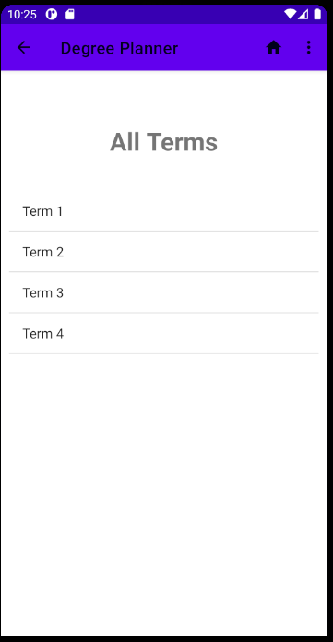

### 

### Term Details

1. To view the details for a particular term, navigate to the “All Terms” screen and select the term from the list.
2. This will navigate the user to the Term Details screen, where the term title, term start date, and term end date are visible.

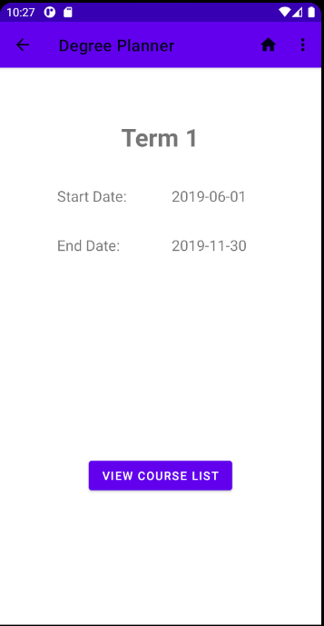

### Add Term

1. To add a term to the degree planner, first navigate to the “Term List” screen.
2. Select “Add Term from the options menu.

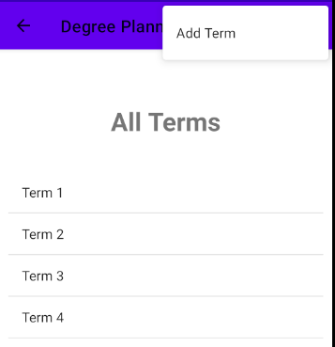

1. The user will be navigated to the “Add Term Screen.” There is a form with spaces to enter the term details of the new term. Enter the term title in the Term Title EditText field.
2. Enter the start and end dates for the new term. Enter dates in the format “yyyy-MM-dd.” An example of a correctly formatted date is “2020-05-27.” If data is not entered in the correct format, the term will not be created and the user will receive an error notification.
3. When the form is complete, tap the “Add Term” button at the bottom of the screen. If the form is not filled out correctly, then an error notification will appear and a new term will not be added. If the data in the form is valid and complete, then the term will be added to the database and the app will switch back to the “Term List” screen. The new term will appear in the list.

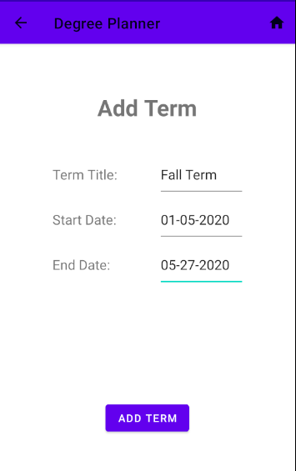

### Update Term

1. To update a term in the degree planner, first navigate to the “Term Details” screen of the term to be updated.
2. Select “Update Term” from the options menu.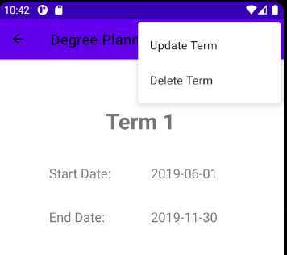
3. The user will be navigated to the “Update Term Screen.” There is a form with spaces to enter the term details of the term to be updated. The details of the term being updated will be automatically filled into the form. Update the data in the form in the field or fields that should be changed. Enter dates in the format “yyyy-MM-dd.”
4. When the form is complete, tap the “Update Term” button at the bottom of the screen. If the form is not filled out correctly, then an error notification will appear and the term will not be updated. If the data in the form is valid and complete, then the term will be updated in the database and the app will switch back to the “Term Details” screen. The details of the updated term will appear on the screen.

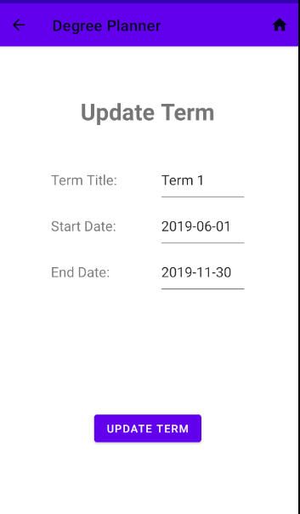

### Delete Term

1. To delete a term, first navigate to the “Term List” screen. Select the term of the term to be deleted.
2. The app will switch to a view of the term’s details. Next, tap the “View Course List” button at the bottom of the screen.

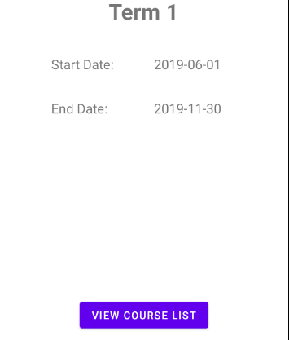

1. The app will switch to the “Course List” screen. This screen displays a list of all the courses in the selected term. If there are any courses in the list, delete them individually. Refer to the “Delete Course” section of the user guide for step-by-step instructions for deleting courses.
2. When there are no courses left in the course list, tap the back button to return to the term details screen.
3. The app will switch to a view of the term’s details. Next, select “Delete Term” from the options menu.

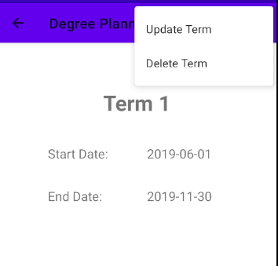

1. A confirmation message will appear on the screen. Select “Yes” to delete the term.

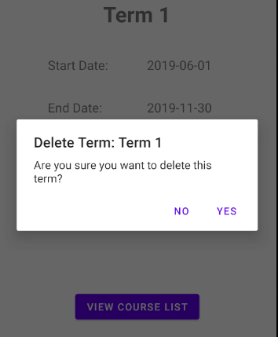

## Courses

### List of Courses

1. Navigate to the “Term List” screen and tap a term on the list.
2. The app will switch to the “Term Details” screen showing the details of the selected term.
3. Tap the “View Course List” button at the bottom of the screen.
4. The app will switch to the “Course List” screen. All the courses in the selected term will be listed on the screen.

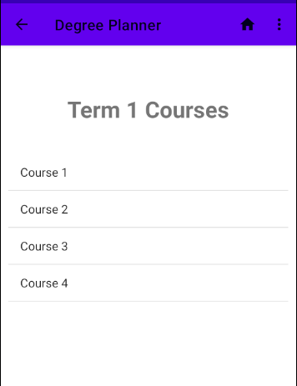

### Course Details

1. To view the details for a particular course, navigate to the “Term List” screen and select the term that contains the desired course.
2. On the “Term Details” screen, tap the “View Course List” button.
3. On the “Course List” screen, tap the course for the course’s details to be displayed.
4. The screen will switch to the “Course Details” screen. All the details for the course will be displayed on the screen.

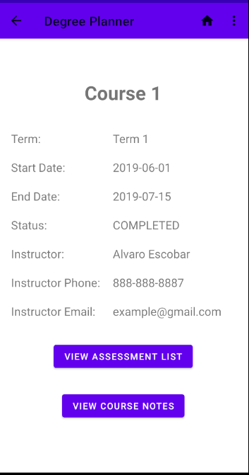

### Add Course

1. To add a course to a particular term, first navigate to the “Term List” screen.
2. Select the term that the course should be added to from the list of terms.
3. On the “Term Details” screen, tap the “View Course List” button.
4. On the “Course List” screen, select “Add Course” from the options menu.

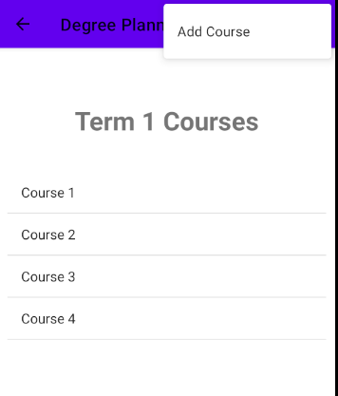

1. The user will be navigated to the “Add Course” screen. There is a form with spaces to enter the course details of the new course. Enter the course title in the Course Title EditText field.
2. Enter the start and end dates for the new course. Enter dates in the format “yyyy-MM-dd.” If data is not entered in the correct format, the course will not be created and the user will receive an error notification.
3. Enter the instructor’s name, phone number and email address in the appropriate fields. Any format is acceptable, but there should be no fields that are empty or contain only white space.
4. Select a radio button for the status of the new course.
5. When the form is complete, tap the “Add Course” button at the bottom of the screen. If the form is not filled out correctly, then an error notification will appear and a new course will not be added. If the data in the form is valid and complete, then the course will be added to the database and the app will switch back to the “Course List” screen. The new course will appear in the selected term’s list of courses.

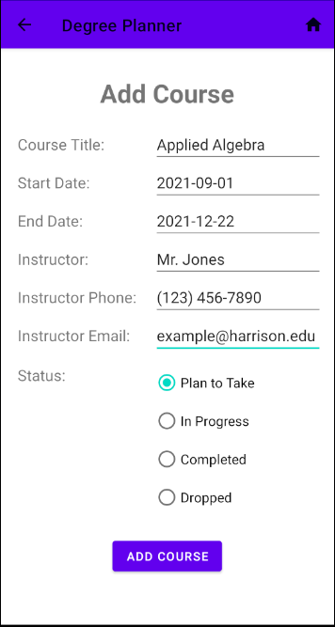

### Update Course

1. To update a course in a particular term, first navigate to the “Term List” screen.
2. Select the term that the course belongs to from the list of terms.
3. On the “Term Details” screen, tap the “View Course List” button.
4. On the “Course List” screen, select the course to be updated from the list of courses.
5. On the “Course Details” screen, select “Update Course” from the options menu.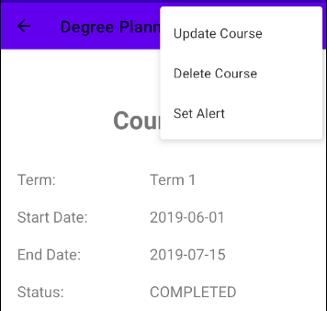
6. The user will be navigated to the “Update Course” screen. There is a form with spaces to enter the course details of the course to be updated. The details of the course being updated will be automatically filled into the form. Update the data in the form in the field or fields that should be changed. Enter dates in the format “yyyy-MM-dd.”
7. When the form is complete, tap the “Update Course” button at the bottom of the screen. If the form is not filled out correctly, then an error notification will appear and the course will not be updated. If the data in the form is valid and complete, then the course will be updated in the database and the app will switch back to the “Course Details” screen. The details of the updated course will appear on the screen.

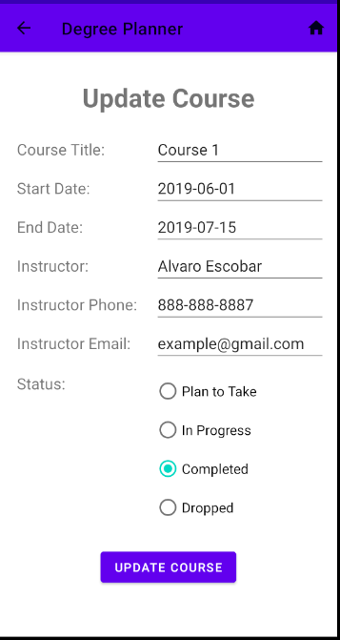

### Delete Course

1. To delete a course, first navigate to the “Course Details” screen for the course to be deleted.
2. Select “Delete Course” from the options menu.

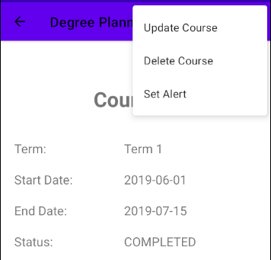

1. A confirmation message will appear on the screen. Select “Yes” to delete the course. All assessments and notes associated with the course will also be deleted.

### Set Course Alert

1. To set an alert for a course start or end date, first navigate to the “Course Details” screen for the course that will have an alert set.
2. Select “Set Alert” from the options menu.
3. The app will switch the screen to the “Set Course Alert” screen. Course alerts are set for 8:00 A.M. local time on the start or end date. Use the switches to toggle alerts for the start and end dates on or off. The alert will go off even if the Harrison University Degree Planner app is not running.
4. If the start or end date for a course is on or before the current date according to the phone’s calendar, an alert cannot be set. The toggle switch for the date will be frozen.
5. To disable an alert, toggle the switch for the start or end date off.

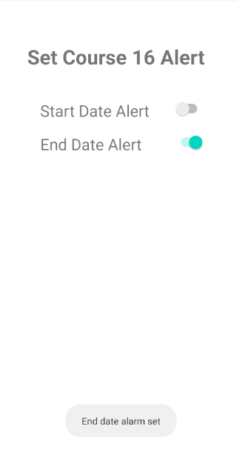

## Assessments

### List of Assessments

1. Navigate to the “Course Details” screen of a course.
2. Tap the “View Assessment List” button to view a list of the selected course’s assessments.

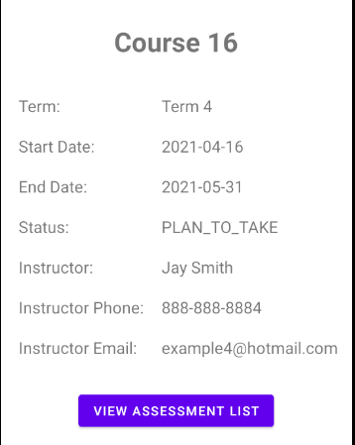

1. The app will switch to the “Assessment List” screen.

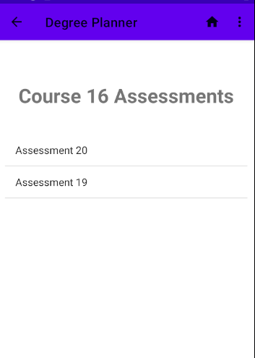

### Assessment Details

1. To view the details for a particular assessment, navigate to the “Assessment List” screen of the course that the assessment belongs to.
2. On the “Assessment List” screen, tap the desired assessment for the assessment’s details to be displayed.
3. The screen will switch to the “Assessment Details” screen. All the details for the assessment will be displayed on the screen.

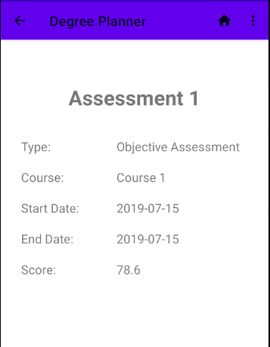

### Add Objective Assessment

1. There are two types of assessments at Harrison University: objective assessments and performance assessments. Objective assessments have a score in the form of a percentage value between 0 and 100. Performance assessments have a pass/fail value instead of a numerical score. To add an objective assessment to a particular course, first navigate to the “Assessment List” screen for that course.
2. On the “Assessment List” screen, select “Add Objective Assessment” from the options menu.

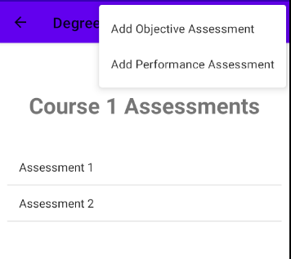

1. The user will be navigated to the “Add Objective Assessment” screen. There is a form with spaces to enter the assessment details of the new assessment. Enter the assessment title in the Assessment Title EditText field.
2. Enter the start and end dates for the new assessment. Enter dates in the format “yyyy-MM-dd.” If data is not entered in the correct format, the assessment will not be created and the user will receive an error notification.
3. If the assessment has already been scored, enter the value as a decimal number in the Score EditText field. The score must be a percentage value between 0 and 100. If the assessment has not been scored, then leave the field blank.
4. When the form is complete, tap the “Add Assessment” button at the bottom of the screen. If the form is not filled out correctly, then an error notification will appear and a new assessment will not be added. If the data in the form is valid and complete (aside from the optional score field), then the assessment will be added to the database and the app will switch back to the “Assessment List” screen. The new assessment will appear in the selected course’s list of assessments.

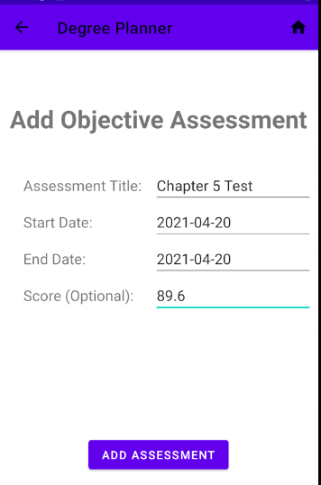

### Add Performance Asssessment

1. To add a performance assessment to a particular course, first navigate to the “Assessment List” screen for that course.
2. On the “Assessment List” screen, select “Add Performance Assessment” from the options menu.
3. The user will be navigated to the “Add Performance Assessment” screen. There is a form with spaces to enter the assessment details of the new assessment.
4. Select a radio button representing the status of the assessment’s outcome.
5. When the form is complete, tap the “Add Assessment” button at the bottom of the screen. If the form is not filled out correctly, then an error notification will appear and a new course will not be added. If the data in the form is valid and complete, then the assessment will be added to the database and the app will switch back to the “Assessment List” screen. The new assessment will appear in the selected course’s list of assessments.

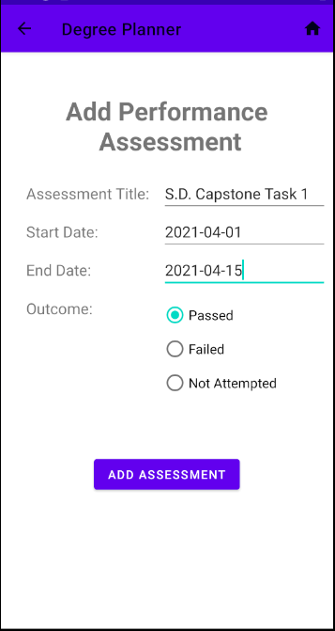

### Update Assessment

1. To update an assessment for a particular term, navigate to the “Assessment Details” screen for that assessment.
2. Select “Update Assessment” from the options menu. 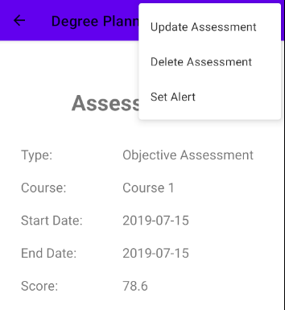
3. The user will be navigated to the “Update Objective Assessment” screen or the “Update Performance Assessment” screen. One both screens, there is a form with spaces to enter the assessment details of the assessment to be updated. The details of the assessment being updated will be automatically filled into the form. Update the data in the form in the field or fields that should be changed. Enter dates in the format “yyyy-MM-dd.”
4. When the form is complete, tap the “Update Assessment” button at the bottom of the screen. If the form is not filled out correctly, then an error notification will appear and the assessment will not be updated. If the data in the form is valid and complete, then the assessment will be updated in the database and the app will switch back to the “Assessment Details” screen. The details of the updated assessment will appear on the screen.

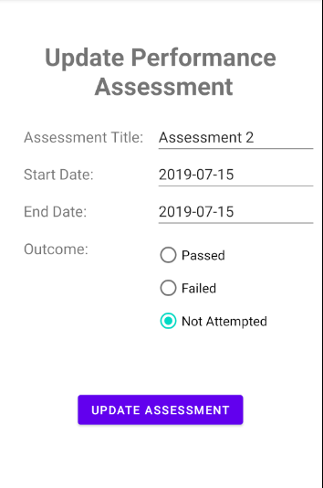

### Delete Assessment

1. To delete an assessment, first navigate to the “Assessment Details” screen for the assessment to be deleted.
2. Select “Delete Assessment” from the options menu.
3. A confirmation message will appear on the screen. Select “Yes” to delete the assessment.

### Set Assessment Alert

1. To set an alert for a course start or end date, first navigate to the “Assessment Details” screen for the assessment that will have an alert set.
2. Select “Set Alert” from the options menu.
3. The app will switch the screen to the “Set Assessment Alert” screen. Assessment alerts are set for 8:00 A.M. local time on the start or end date. Use the switches to toggle alerts for the start and end dates on or off. The alert will go off even if the Harrison University Degree Planner app is not running.
4. If the start or end date for an assessment is on or before the current date according to the phone’s calendar, an alert cannot be set. The toggle switch for the date will be frozen.
5. To disable an alert, toggle the switch for the start or end date off.

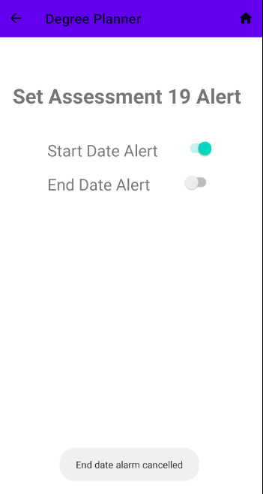

## Course Notes

### List of Course Notes

1. Navigate to the “Course Details” screen of a course.
2. Tap the “View Course Notes” button to view a list of the selected course’s course notes.

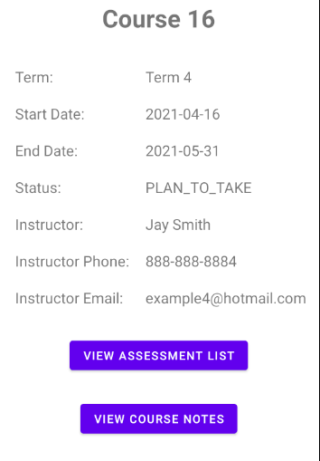

1. The app will switch to the “Course Notes List” screen.

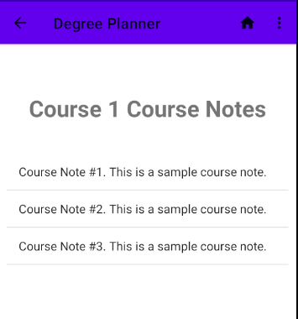

### 

### Add Course Note

1. To add a course note to a particular course, first navigate to the “Course Notes List” screen of the course the note will belong to.
2. On the “Course Notes List” screen, select “Add Course Note” from the options menu.

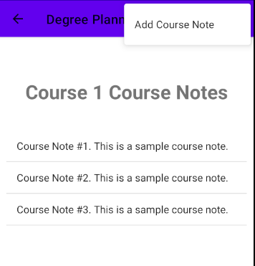

1. The user will be navigated to the “Add Course Note” screen. Enter the text of the course note in the EditText field on the screen.
2. Tap the “Add Course Note” button at the bottom of the screen to save the course note. The course note will be added to the database and the app will switch back to the “Course Notes List” screen. The new course note will appear in the selected course’s list of course notes.

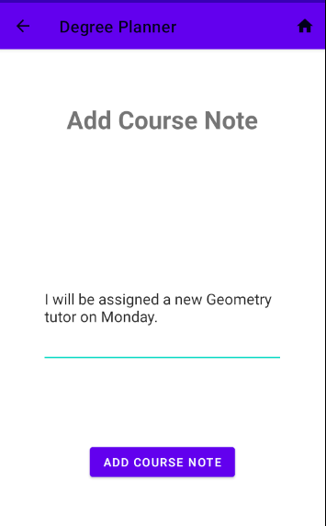

### Update Course Note

1. To update a course note for a particular course, navigate to the “Course Note List” screen for that course.
2. Select the course note to be updated from the list of courses.
3. The user will be navigated to the “Update Course Note” screen. The text of the note will appear in the EditText field where it can be modified.
4. When note has been edited, tap the “Update Course Note” button at the bottom of the screen. If the field is not empty, then the course note will be updated in the database and the app will switch back to the “Course Notes List” screen. The updated note will appear on the screen.

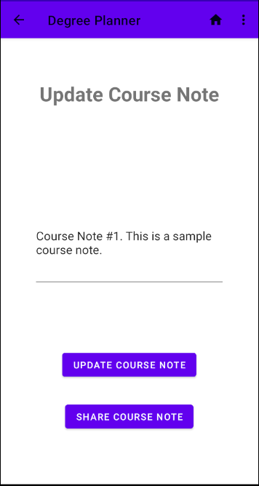

### Delete Course Note

1. To delete a course note, first navigate to the “Course Note List” screen for the course the note belongs to.
2. Select the course note to be deleted from the list of course notes.
3. On the “Update Course Note” screen, select “Delete Course Note” from the options menu.

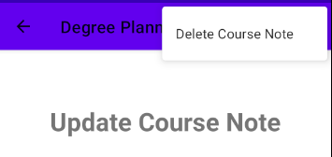

1. A confirmation message will appear on the screen. Select “Yes” to delete the course note.

### Share Course Note

1. To share the course note by email or SMS, first navigate to the “Update Course Note” screen for the course note to be sent.
2. Tap the “Share Course Note” button at the bottom of the screen.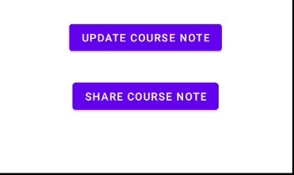
3. A popup will appear with options to send the course note. Select the way to send the note, such as by text message. In that case, the course note will be automatically populated in the Messages app.

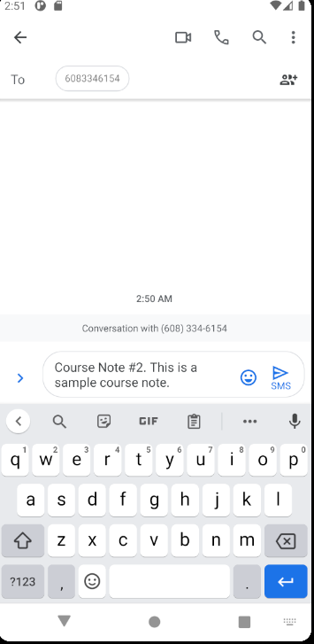

## Search Courses

1. To perform a course search, navigate to the home screen by tapping the home button.
2. Tap the “Search all Courses” button. This will navigate the user to the “Course Search” screen.
3. Type a query into the “Find Course” EditText field.
4. Tap the search button to perform a search for courses matching the query. The results will appear in a list on the screen.

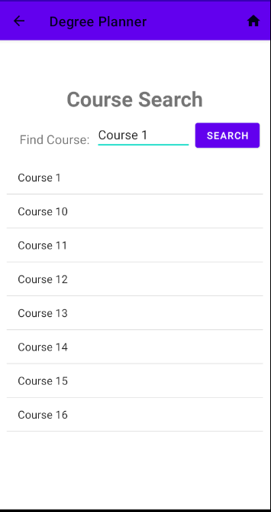

1. Select a course from the search results to navigate to the “Course Details” page for that course.

## Generate Reports

### Generate Courses Report

1. To generate a report, navigate to the home screen by tapping the home button.
2. Tap the “Generate Report” button. This will navigate the user to the “Generate Report Menu” screen.

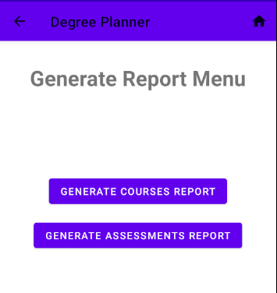

1. Tap the “Generate Courses Report” button.
2. A report displaying the number of courses in each term organized by course status will appear on the “Courses Report” screen.

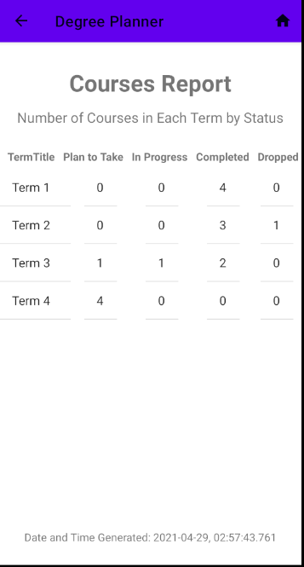

### Generate Assessments Report

1. To generate a report, navigate to the home screen by tapping the home button.
2. Tap the “Generate Report” button. This will navigate the user to the “Generate Report Menu” screen.
3. Tap the “Generate Assessments Report” button.

A report displaying the number of assessments in each term organized by assessment type will appear on the “Assessments Report” screen.

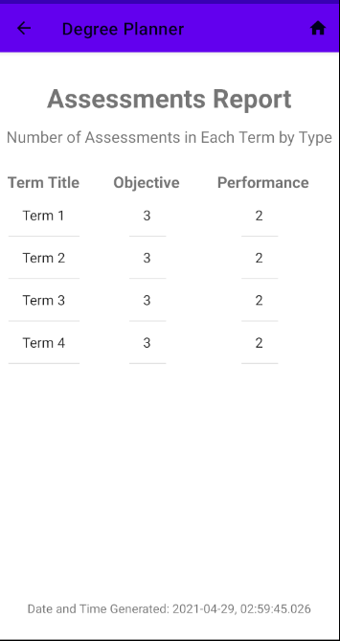

## Reset Database

1. To reset the database, navigate to the home screen.
2. Tap the “Reset Database” button. This will clear all the data in the database.

## Populate Sample Data

1. To populate the database with sample data, navigate to the home screen.
2. Tap the “Populate Sample Data” button. This will clear the database and populate it with filler terms, courses, assessments and course notes.